- Vectors
1. Given that 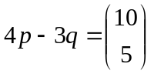and 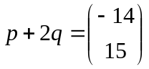find
    - (i) 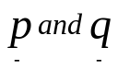 (3 mks)
  - |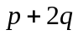| (3 mks)
- Show that A (1, -1), B (3, 5) and C (5, 11) are collinear (4 mks)
2. Given the column vectors 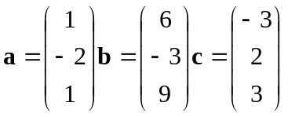and that 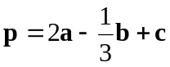
- (i) Express p as a column vector (2mks)
- (ii) Determine the magnitude of p (1mk)
3. Given the points P(-6, -3), Q(-2, -1) and R(6, 3) express PQ and QR as column vectors. Hence show that the points P, Q and R are collinear. (3mks)

4. The position vectors of points x and y are 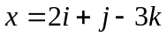and 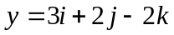respectively. Find x y as a column vector (2 mks)
5. Given that 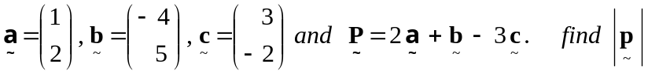 (3mks)
6. The position vectors of A and B are 2 and 8 respectively. Find the coordinates of M
5 -7
which divides AB in the ratio 1:2. (3 marks)

7. The diagram shows the graph of vectors 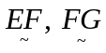 and 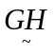.
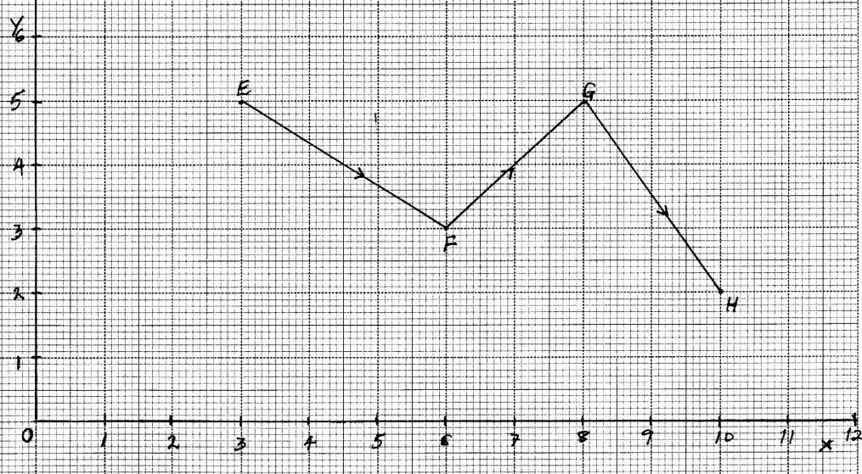
Find the column vectors;
(a) 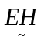 (1mk)
(b) || (2mks)
8. 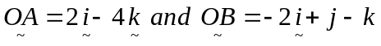. Find 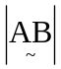 (2mks)
9. Show that P (4, 0 -4), Q (8, 2, -1) and R (24, 10, 11) are collinear. (3 mks)
10. Given that = 2i – j + k and q = i + j +2k, determine
a. │p + q│ (1 mk)
(b) │ ½ p – 2q │ (2 mks)
11. Express in surds form and rationalize the denominator.
1
Sin 60º Sin 45º - Sin 45º

12. If OA = 12i + 8j and OB = 16i + 4j. Find the coordinates of the point which divides AB
~
~
~
~
internally in the ratio1:3

13. Find scalars m and n such that

m 4 + n -3 = 5
3 2 8

14. In a triangle OAB, M and N are points on OA and OB respectively, such that OM: MA = 2:3
and ON: NB = 2:1. AN and BM intersect at X. Given that OA = a and OB = b
B
A
O
M
N
~
~

(a) Express in terms of a and b
~
~
(i) BM
(ii) AN
(b) By taking BX = t and AX = h AN, where t and h are scalars, express OX in two
different ways
(c) Find the values of the scalars t and h
(d) Determine the ratios in which X divides :-
(i) BM
(ii) AN

15. OABC is a parallelogram, M is the mid-point of OA and AX = ²/₇ AC, OA=a and OC = c
∼
∼
O
M
A
Y
B
C

(a) Express the following in terms of a and c
∼
∼
(i) MA
(ii) AB
(iii) AC
(iv) AX
(b) Using triangle MAX, express MX in terms of a and c
(c)The co-ordinates of A and B are (1, 6, 8) and (3, 0, 4) respectively. If O is the origin and P
the midpoint of AB. Find;
(i) Length of OP
(ii) How far are the midpoints of OA and OB?

16. a) If A, B & C are the points (2, - 4), (4, 0) and (1, 6) respectively, use the vector method
to find the coordinates of point D given that ABCD is a parallelogram.
b) The position vectors of points P and Q are p and q respectively. R is another point with
~
~
~
position vector r = ³/₂ q - ½ p. Express in terms of P and q
~
~

~
~
(i) PR
(ii) PQ, hence show that P, Q & R are collinear.
(iii) Determine the ratio PQ : QR

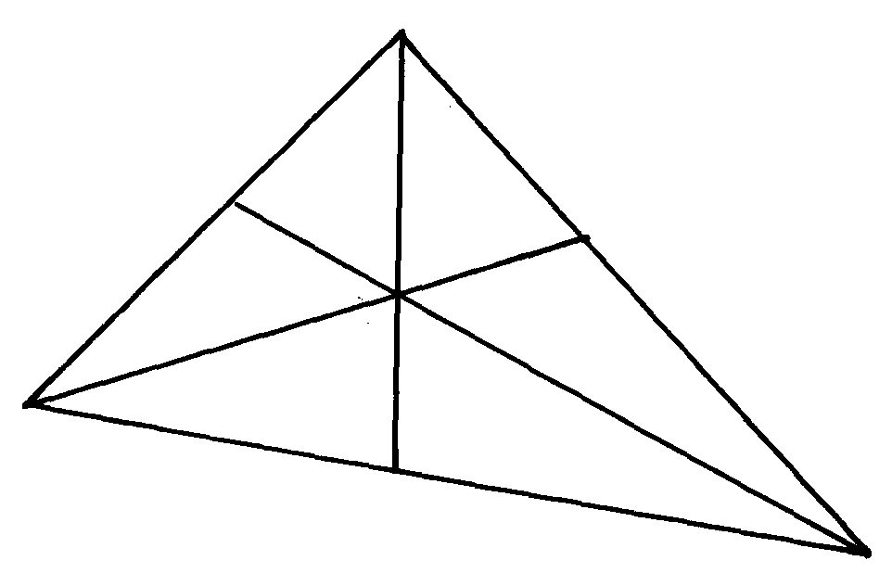
17. The figure shows a triangle of vectors in which OS: SP = 1:3, PR:RQ = 2:1 and T is the
T
Q
R
P
O
S
M
midpoint of OR

a) Given that OP = p and OQ = q, express the following vectors in terms of P and q
i) OR
ii) QT
b) Express TS in terms of p and q and hence show that the points Q, T and S are collinear
c) M is a point on OQ such that OM = KOQ and PTM is a straight line. Given that
PT: TM = 5:1, find the value of k

18. Given that a = , b = and c = and that p = 3q – ½ b +¹/₁₀c
Express p as a column vector and hence calculate its magnitude /P/ correct to two decimal places

19. In a triangle OAB, M and N are points on OA and OB respectively, such that OM:MA= 2:3 and
ON:NB= 2:1. AN and BM intersect at X. Given that OA = a and OB = b
~
~
(a) Express in terms of a and b:-
~
~
(i) BM
~
(ii) AN
~
(b) Taking BX = kBM and AX =hAN where k and h are constants express OX in terms of
~
~
~
~
~
~
(i) a, b and k only
~
~
~
(ii) a, b, and h only
~
~
(c) Use the expressions in (b) above to find values of k and h
.
20. In the figure below OAB is a triangle in which M divides OA in the ratio 2:3 and N
divides OB in the ratio 4:1. AN and BM intersects at X
X
X
A
O
M
B
N

(a) Given that OA = a and OB = b, express in terms of a and b
∼
∼
∼
∼
(i) AN
∼
(ii) BM
∼
(iii) AB
∼
(b) If AX = sAN and BX = tBM, where s and t are constants, write two expressions
~
~
~
~
for OX in terms of a, b, s and t. Find the value of s and t hence write OX in terms
of a and b

21. A student traveling abroad for further studies sets a side Kshs. 115800 to be converted into US
dollars through a bank at the rate of 76.84 per dollar. The bank charges a commission of 2 ½ %
of the amount exchanged. If he plans to purchase text books and stationery worth US$270, how
much money, to the nearest dollar, will he be left with?

22. Given that:- r = 5i – 2j and m = -2i + 6j – k are the position vectors for R and M respectively.
~
~
~
~
~
~
~
Find the length of vector RM
~

23. OABC is a trapezium in which OA = a and AB = b. AB is parallel to OC with 2AB = OC.
~
~
~
~
~
~
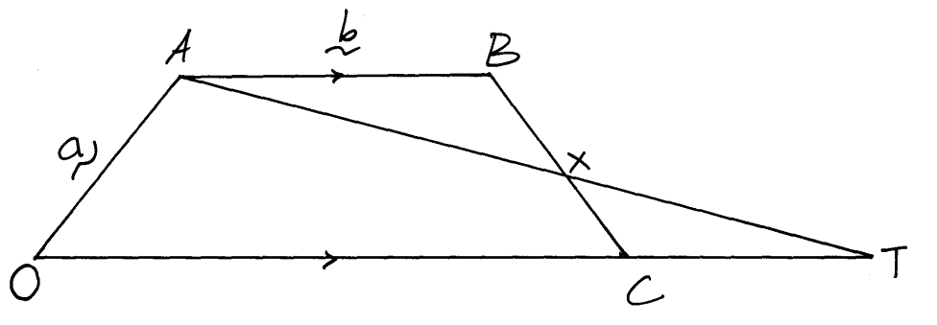
T is a point on OC produced so that OC: CT = 2:1. At and BC intersect at X so that BX = hBC and AX = KAT
~
~

(a) Express the following in terms of a and b:-
~
~
(i) OB
~
(ii) BC
~
(b) Express CX in terms of a, b and h
~
~
~
(c) Express CX in terms of a, b and k
~
~
~
(d) Hence calculate the values of h and k

24. Given that a = 2i + j – 2k and b = -3i + 4j – k find :-
~~
~
| a + b|.

25. In the figure below, E is the mid-point of BC. AD:DC=3:2 and F is the meeting point of
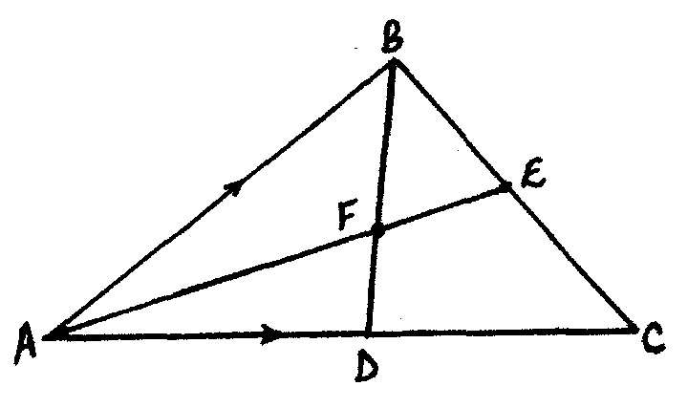
BD and AE

If AB = b and AC = c;
~
~
(i) Express BD and AE in terms of b and c
~
~
~
~
(ii) If BF =tBD and AF =nAE, find the values of t ad n
(iii) State the ratios in which F divides BD and AE

26. The coordinates of point O, A, B and C are (0, 0) (3, 4) (11, 6) and (8, 2) respectively.
A point P is such that the vector OP, BA, BC satisfy the vector equation OP = BA + ½ BC
Find the coordinates of P

27. A point Q divides AB in the ratio 7:2. Given that A is (-3, 4) and B(2, -1).
Find the co-ordinates of Q

